Design and implementation Document:

* The Blackjack game on the console is implemented by the provided Python code.
* The Player, Card, Deck, and BlackjackGame classes are defined.
* A player with name and balance qualities is represented by the Player class.
* A card with a value is represented by the Card class.
* The Deck class initializes a deck of cards, shuffles them, and allows drawing cards.
* The player's cards, amounts, and messages are all managed by the BlackjackGame class.
* Methods like start_game, calculate_sum, render_game, and computer_turn carry out the implementation of the game logic.
* The primary purpose is to establish the rules of the game, permit card drawing, and decide the winner.

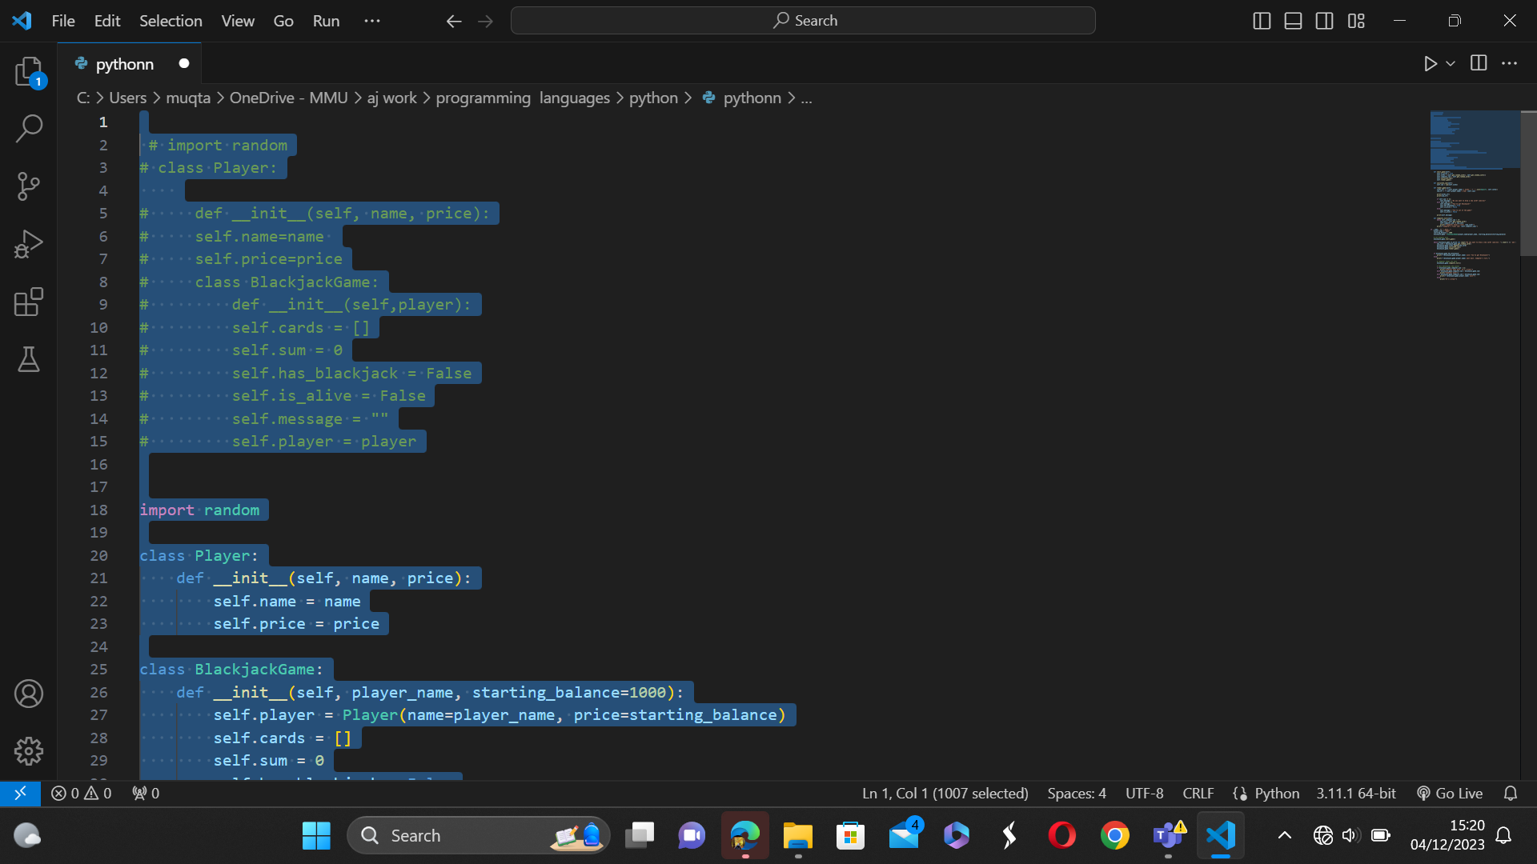

In this section defines the codes behaviour of blackjack game and it has constryuctor that takes player object as a parameter.

In this section I changed my code by trying to add more classes. The classes I added defines which paradigm I used which is object orianted. This section the Dec class encapsulates the functionality related to managung and interacting with a deck of cards

I used shuffle method because is essential for the game and its used to randomize the order of cards. Also I used draw card method to simulate drawing catd from the deck.

I had to add this line because the because this line represents the player in the Blackjacak game.

The get random card is responsible for simulating the process of drawing a random card from the deck. Also, the start game, this method initialies the game when called, and it has boolean method which sets the ‘is Alive’ which indicates the player is still in the game.

I also used render game in this line of code, this method prints the current state of the game to the console.

I set the players name As Abdi which is me and I also set the balance which is 1000.

This line of code determines the outcome of the game after the player has finished their turn.

As you can see here I am getiing an error, it seems like the tsrat game method is not recognised.

This shows the outcome of the game but it doesn’t allow me to take my turn and the computer.

Now this is my final game and it works perfectly.